[Skip Navigation](https://www.chegg.com/homework-help/questions-and-answers/pi-30--write-computer-program-takes-initial-horizontal-vertical-position-projectile-along--q31946282" \l "main-content-start)

[Chegg study](https://www.chegg.com/study)

[Textbook Solutions](https://www.chegg.com/study/tbs)

[Expert Q&A](https://www.chegg.com/study/qa)

[Study Pack](https://www.chegg.com/study-pack)

[Practice](https://www.chegg.com/study/v2/practice)



Top of Form

Find solutions for your homework or get textbooks

Bottom of Form

[home](https://www.chegg.com/) / [study](https://www.chegg.com/study) / [engineering](https://www.chegg.com/homework-help/engineering) / [computer science](https://www.chegg.com/homework-help/engineering-computer-science-s3) / [computer science questions and answers](https://www.chegg.com/homework-help/questions-and-answers/computer-science-archive) / pi (30%). write a computer program that takes the initial horizontal and vertical position ...

# **Question: PI (30%). write a computer program that takes the initial horizontal and vertical position of a p...**

The answer should be written in MatLab language.  
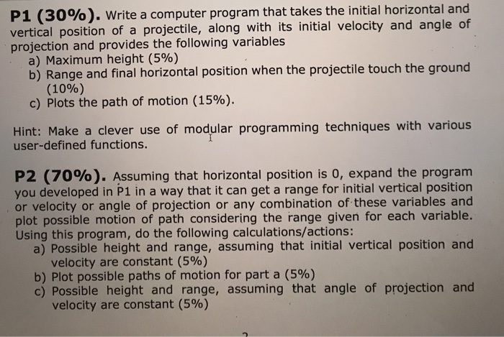

Show transcribed image text

## Expert Answer

* Philip's Avatar

Philip Chegg expert answered this

Was this answer helpful?

1

1

1,806 answers

**Part 1)**

**Program:**

**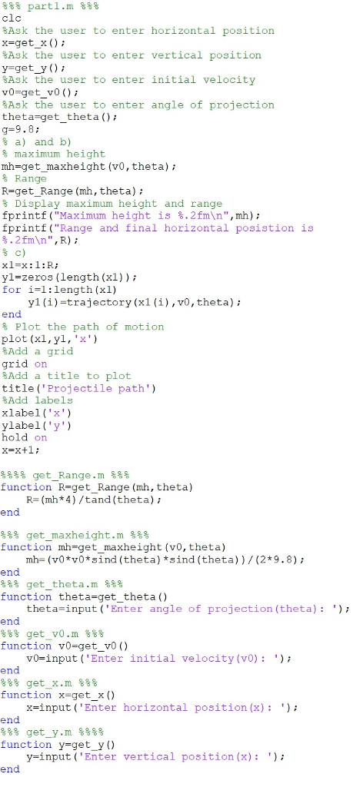**

**Sample output:**

**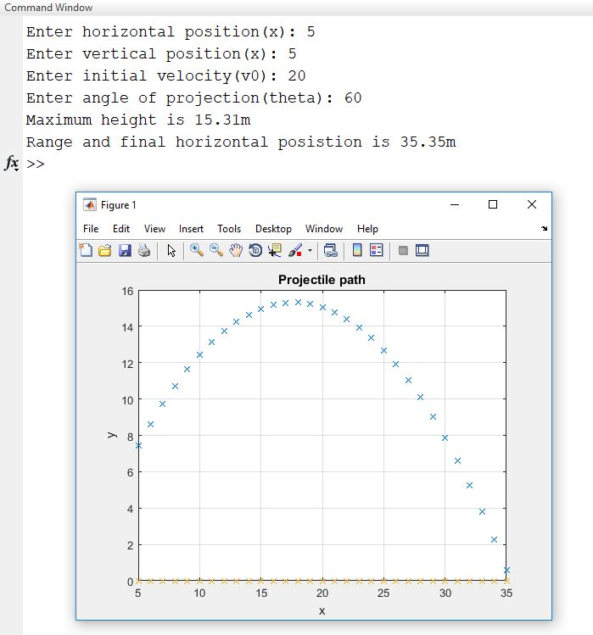**

**Code to copy:**

%%% part1.m %%%

clc

%Ask the user to enter horizontal position

x=get\_x();

%Ask the user to enter vertical position

y=get\_y();

%Ask the user to enter initial velocity

v0=get\_v0();

%Ask the user to enter angle of projection

theta=get\_theta();

g=9.8;

% a) and b)

% maximum height

mh=get\_maxheight(v0,theta);

% Range

R=get\_Range(mh,theta);

% Display maximum height and range

fprintf("Maximum height is %.2fm\n",mh);

fprintf("Range and final horizontal posistion is %.2fm\n",R);

% c)

x1=x:1:R;

y1=zeros(length(x1));

for i=1:length(x1)

    y1(i)=trajectory(x1(i),v0,theta);

end

% Plot the path of motion

plot(x1,y1,'x')

%Add a grid

grid on

%Add a title to plot

title('Projectile path')

%Add labels

xlabel('x')

ylabel('y')

hold on

x=x+1;

%%%% get\_Range.m %%%

function R=get\_Range(mh,theta)

    R=(mh\*4)/tand(theta);

end

%%% get\_maxheight.m %%%

function mh=get\_maxheight(v0,theta)

    mh=(v0\*v0\*sind(theta)\*sind(theta))/(2\*9.8);

end

%%% get\_theta.m %%%

function theta=get\_theta()

    theta=input('Enter angle of projection(theta): ');

end

%%% get\_v0.m %%%

function v0=get\_v0()

    v0=input('Enter initial velocity(v0): ');

end

%%% get\_x.m %%%

function x=get\_x()

    x=input('Enter horizontal position(x): ');

end

%%% get\_y.m %%%%

function y=get\_y()

    y=input('Enter vertical position(x): ');

end

**Part 2)**

**Program:**

**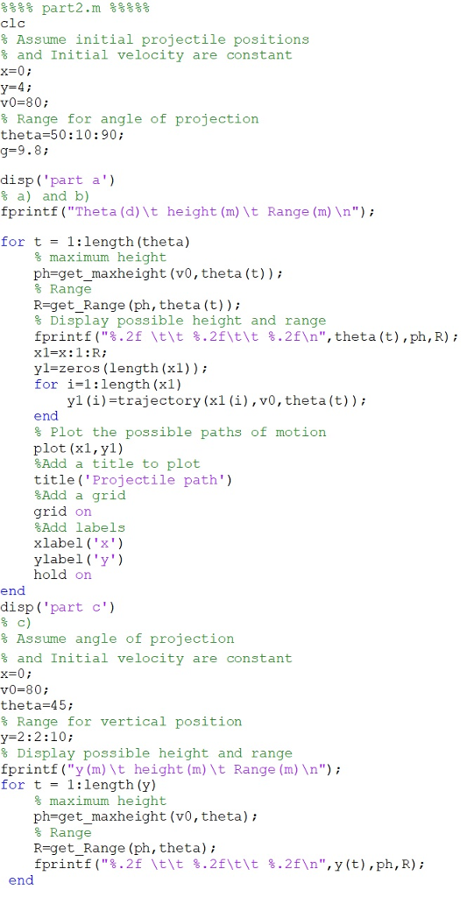**

**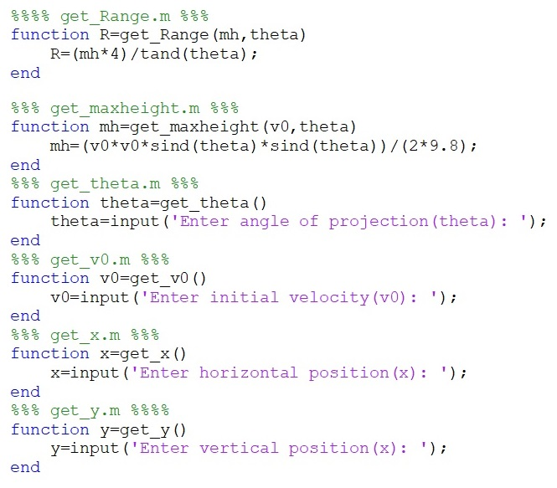**

**Sample output:**

**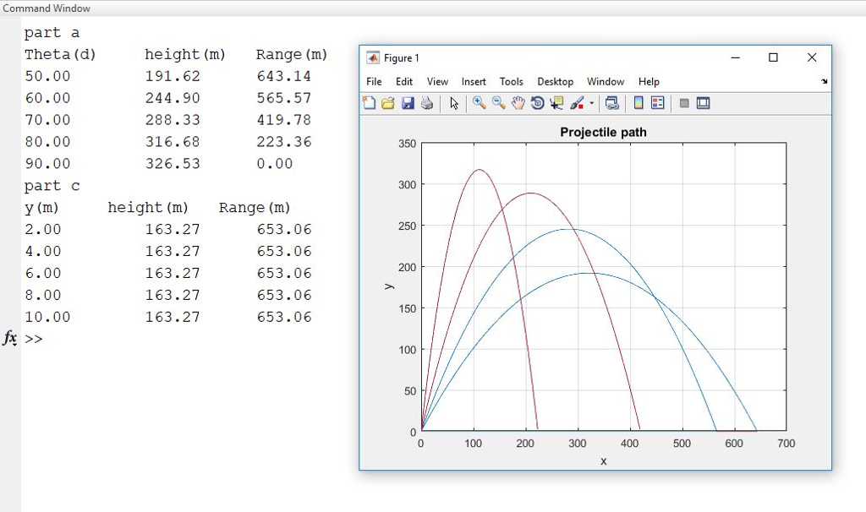**

**Code to copy:**

%%%% part2.m %%%%%

clc

% Assume initial projectile positions

% and Initial velocity are constant

x=0;

y=4;

v0=80;

% Range for angle of projection

theta=50:10:90;

g=9.8;

disp('part a')

% a) and b)

fprintf("Theta(d)\t height(m)\t Range(m)\n");

for t = 1:length(theta)

    % maximum height

    ph=get\_maxheight(v0,theta(t));

    % Range

    R=get\_Range(ph,theta(t));

    % Display possible height and range

    fprintf("%.2f \t\t %.2f\t\t %.2f\n",theta(t),ph,R);

    x1=x:1:R;

    y1=zeros(length(x1));

    for i=1:length(x1)

        y1(i)=trajectory(x1(i),v0,theta(t));

    end

    % Plot the possible paths of motion

    plot(x1,y1)

    %Add a title to plot

    title('Projectile path')

    %Add a grid

    grid on

    %Add labels

    xlabel('x')

    ylabel('y')

    hold on

end

disp('part c')

% c)

% Assume angle of projection

% and Initial velocity are constant

x=0;

v0=80;

theta=45;

% Range for vertical position

y=2:2:10;

% Display possible height and range

fprintf("y(m)\t height(m)\t Range(m)\n");

for t = 1:length(y)

    % maximum height

    ph=get\_maxheight(v0,theta);

    % Range

    R=get\_Range(ph,theta);

    fprintf("%.2f \t\t %.2f\t\t %.2f\n",y(t),ph,R);

end

%%%% get\_Range.m %%%

function R=get\_Range(mh,theta)

    R=(mh\*4)/tand(theta);

end

%%% get\_maxheight.m %%%

function mh=get\_maxheight(v0,theta)

    mh=(v0\*v0\*sind(theta)\*sind(theta))/(2\*9.8);

end

%%% get\_theta.m %%%

function theta=get\_theta()

    theta=input('Enter angle of projection(theta): ');

end

%%% get\_v0.m %%%

function v0=get\_v0()

    v0=input('Enter initial velocity(v0): ');

end

%%% get\_x.m %%%

function x=get\_x()

    x=input('Enter horizontal position(x): ');

end

%%% get\_y.m %%%%

function y=get\_y()

    y=input('Enter vertical position(x): ');

end

[View comments (1)](https://www.chegg.com/homework-help/questions-and-answers/pi-30--write-computer-program-takes-initial-horizontal-vertical-position-projectile-along--q31946282)

Practice with similar questions

[Q:](https://www.chegg.com/homework-help/questions-and-answers/pi-30--write-computer-program-takes-initial-horizontal-vertical-position-projectile-along--q32117102" \t "_blank)

[The code should be written in Matlab Thanks](https://www.chegg.com/homework-help/questions-and-answers/pi-30--write-computer-program-takes-initial-horizontal-vertical-position-projectile-along--q32117102" \t "_blank)

[A:](https://www.chegg.com/homework-help/questions-and-answers/pi-30--write-computer-program-takes-initial-horizontal-vertical-position-projectile-along--q32117102" \t "_blank)

[See answer](https://www.chegg.com/homework-help/questions-and-answers/pi-30--write-computer-program-takes-initial-horizontal-vertical-position-projectile-along--q32117102" \t "_blank)

Questions viewed by other students

[Q:](https://www.chegg.com/homework-help/questions-and-answers/pi-30--write-computer-program-followings-takes-user-inputs-initial-vertical-position-proje-q35425115" \t "_blank)

[Using MatLab please.](https://www.chegg.com/homework-help/questions-and-answers/pi-30--write-computer-program-followings-takes-user-inputs-initial-vertical-position-proje-q35425115" \t "_blank)

[A:](https://www.chegg.com/homework-help/questions-and-answers/pi-30--write-computer-program-followings-takes-user-inputs-initial-vertical-position-proje-q35425115" \t "_blank)

[See answer](https://www.chegg.com/homework-help/questions-and-answers/pi-30--write-computer-program-followings-takes-user-inputs-initial-vertical-position-proje-q35425115" \t "_blank)

[Q:](https://www.chegg.com/homework-help/questions-and-answers/write-matlab-graphical-user-interface-gui-simulate-plot-projectile-motion-motion-object-pr-q19460278" \t "_blank)

[Write a MATLAB Graphical User Interface (GUI) to simulate and plot the projectile motion – the motion of an object projected into the air at an angle. The object flies in the air until the projectile returns to the horizontal axis (x-axis), where y=0. This MATLAB program should allow the user to try to hit a 2-m diameter target on the x-axis (y=0) by varying conditions, including...](https://www.chegg.com/homework-help/questions-and-answers/write-matlab-graphical-user-interface-gui-simulate-plot-projectile-motion-motion-object-pr-q19460278" \t "_blank)

[A:](https://www.chegg.com/homework-help/questions-and-answers/write-matlab-graphical-user-interface-gui-simulate-plot-projectile-motion-motion-object-pr-q19460278" \t "_blank)

[See answer](https://www.chegg.com/homework-help/questions-and-answers/write-matlab-graphical-user-interface-gui-simulate-plot-projectile-motion-motion-object-pr-q19460278" \t "_blank)

[Show more](https://www.chegg.com/homework-help/questions-and-answers/pi-30--write-computer-program-takes-initial-horizontal-vertical-position-projectile-along--q31946282)

Post a question

Answers from our experts for your tough homework questions

Top of Form

Continue to post

12 questions remaining

Bottom of Form

My Textbook Solutions

[](https://www.chegg.com/homework-help/facilities-planning-4th-edition-solutions-9780470444047)

[Facilities Planning](https://www.chegg.com/homework-help/facilities-planning-4th-edition-solutions-9780470444047)

[4th Edition](https://www.chegg.com/homework-help/facilities-planning-4th-edition-solutions-9780470444047)

[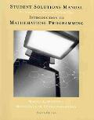](https://www.chegg.com/homework-help/student-solutions-manual-for-winston-s-introduction-to-mathematical-programming-applications-and-algorithms-4th-edition-solutions-9780534399030)

[Student Solutions...](https://www.chegg.com/homework-help/student-solutions-manual-for-winston-s-introduction-to-mathematical-programming-applications-and-algorithms-4th-edition-solutions-9780534399030)

[4th Edition](https://www.chegg.com/homework-help/student-solutions-manual-for-winston-s-introduction-to-mathematical-programming-applications-and-algorithms-4th-edition-solutions-9780534399030)

[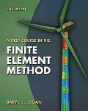](https://www.chegg.com/homework-help/a-first-course-in-the-finite-element-method-5th-edition-solutions-9781133169055)

[A First Course in...](https://www.chegg.com/homework-help/a-first-course-in-the-finite-element-method-5th-edition-solutions-9781133169055)

[5th Edition](https://www.chegg.com/homework-help/a-first-course-in-the-finite-element-method-5th-edition-solutions-9781133169055)

[View all solutions](https://www.chegg.com/study/tbs)

Computer Science Chegg tutors who can help right now

[](https://www.chegg.com/tutors/Computer-Science-online-tutoring/?filter-highlight_tutor=Swati-J-0630271)

[Swati J.](https://www.chegg.com/tutors/Computer-Science-online-tutoring/?filter-highlight_tutor=Swati-J-0630271)

[RGPV University](https://www.chegg.com/tutors/Computer-Science-online-tutoring/?filter-highlight_tutor=Swati-J-0630271)

[161](https://www.chegg.com/tutors/Computer-Science-online-tutoring/?filter-highlight_tutor=Swati-J-0630271)

[](https://www.chegg.com/tutors/Computer-Science-online-tutoring/?filter-highlight_tutor=Mohsen-H-1109390)

[Mohsen H.](https://www.chegg.com/tutors/Computer-Science-online-tutoring/?filter-highlight_tutor=Mohsen-H-1109390)

[University of Saskatchewan](https://www.chegg.com/tutors/Computer-Science-online-tutoring/?filter-highlight_tutor=Mohsen-H-1109390)

[35](https://www.chegg.com/tutors/Computer-Science-online-tutoring/?filter-highlight_tutor=Mohsen-H-1109390)

[](https://www.chegg.com/tutors/Computer-Science-online-tutoring/?filter-highlight_tutor=Sourabh-J-1561320)

[Sourabh J.](https://www.chegg.com/tutors/Computer-Science-online-tutoring/?filter-highlight_tutor=Sourabh-J-1561320)

[NIT Bhopal](https://www.chegg.com/tutors/Computer-Science-online-tutoring/?filter-highlight_tutor=Sourabh-J-1561320)

[14](https://www.chegg.com/tutors/Computer-Science-online-tutoring/?filter-highlight_tutor=Sourabh-J-1561320)

[Find me a tutor](https://www.chegg.com/tutors/Computer-Science-online-tutoring/)

#### ABOUT CHEGG

* [Become a Tutor](https://www.chegg.com/tutors/become-a-tutor/)
* [Chegg For Good](https://www.chegg.com/play/student-life/chegg-for-good/)
* [College Marketing](https://collegemarketing.chegg.com/)
* [Corporate Development](https://corpdev.chegg.com/)
* [Investor Relations](https://investor.chegg.com/)
* [Jobs](https://jobs.chegg.com/)
* [Join Our Affiliate Program](https://www.chegg.com/affiliate-program/)
* [Media Center](https://www.chegg.com/press/)
* [Site Map](https://www.chegg.com/sitemap/)

#### LEGAL & POLICIES

* [Advertising Choices](http://preferences-mgr.truste.com/?pid=chegg01&aid=chegg_pub02&type=cheggdirect)
* [Cookie Notice](https://www.chegg.com/cookienotice/)
* [General Policies](https://www.chegg.com/generalpolicies/)
* [Intellectual Property Rights](https://www.chegg.com/copyright/)
* [Terms of Use](https://www.chegg.com/termsofuse/)
* [Chegg Tutors Terms of Service](https://www.chegg.com/tutoringterms/)
* [Global Privacy Policy](https://www.chegg.com/privacypolicy/)
* [California Privacy Rights](https://www.chegg.com/caprivacypolicy/)
* [Honor Code](https://www.chegg.com/honorcode)

#### CHEGG PRODUCTS AND SERVICES

* [Cheap Textbooks](https://www.chegg.com/cheap-textbooks/)
* [Chegg Coupon](https://www.chegg.com/chegg-coupon/)
* [Chegg Play](https://www.chegg.com/play/)
* [Chegg Study Help](https://www.chegg.com/study/)
* [College Textbooks](https://www.chegg.com/college-textbooks/)
* [eTextbooks](https://www.chegg.com/etextbooks/)
* [Chegg Math Solver](https://www.chegg.com/math-solver/)
* [Mobile Apps](https://www.chegg.com/mobile/)
* [Online Tutoring](https://www.chegg.com/tutors/)
* [Solutions Manual](https://www.chegg.com/homework-help/solutions-manual/)
* [Study 101](https://www.chegg.com/study-101/)
* [Test Prep](https://www.chegg.com/test-prep/)
* [Textbook Rental](https://www.chegg.com/textbooks/)
* [Used Textbooks](https://www.chegg.com/used-textbooks/)
* [Digital Access Codes](https://www.chegg.com/access-codes/)

#### CHEGG NETWORK

* [Easybib](https://www.easybib.com/)
* [Internships.com](https://www.internships.com/)
* [Studyblue](https://www.studyblue.com/)
* [Thinkful](https://www.thinkful.com/)

#### CUSTOMER SERVICE

* [Customer Service](https://www.chegg.com/contactus/)
* [Give Us Feedback](mailto:danlr@chegg.com)
* [Help with Chegg Tutors](https://www.chegg.com/contactus/#/path/Chegg-Tutors/I-m-a-Student-Parent/)
* [Help with eTextbooks](https://www.chegg.com/contactus/#/path/eTextbooks/)
* [Help to use EasyBib Plus](https://www.chegg.com/contactus/#/path/Writing/How-to-Use-Writing/)
* [Manage Chegg Study Subscription](https://www.chegg.com/contactus/#/path/Chegg-Study/Managing-My-Membership/)
* [Return Your Books](https://www.chegg.com/returnbooks/)
* [Textbook Return Policy](https://www.chegg.com/contactus/#/path/Textbooks/Returns/)

[Paypal verified](http://www.paypal.com/) [Better Business Bureau Seal](http://www.bbb.org/sanjose/business-reviews/books-textbooks-new-and-used/cheggcom-in-santa-clara-ca-238456) 